2004 Mech. 1 Name:

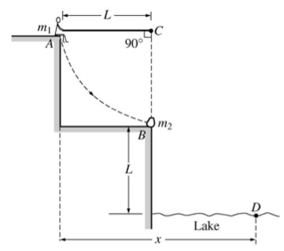
A rope of length L is attached to a support at point C. A person of mass m₁ sits on a ledge at position A holding the other end of the rope so that it is horizontal and taut, as shown. The person then drops off the ledge and swings down on the rope toward position B on a lower ledge where an object of mass m₂ is at rest. At position B the person grabs hold of the object and simultaneously lets go of the rope. The person and object then land together in the lake at point D, which is a vertical distance L below position B. Air resistance and the mass of the rope are negligible. Derive expressions for each of the following in terms of m₁, m₂, L, and g.

a. The speed of the person just before the collision with the object

b. The tension in the rope just before the collision with the object

c. The speed of the person and object just after the collision

d. The ratio of the kinetic energy of the person-object system before the collision to the kinetic energy after the collision

e. The total horizontal displacement x of the person from position A until the person and object land in the water at point D.

