Ch 1 – 3 Review Name: Per:

2003Bb1. (15 points) An airplane accelerates uniformly from rest. A physicist passenger holds up a thin string of negligible mass to which she has tied her ring, which has a mass m. She notices that as the plane accelerates down the runway, the string makes an angle θ with the vertical as shown above.
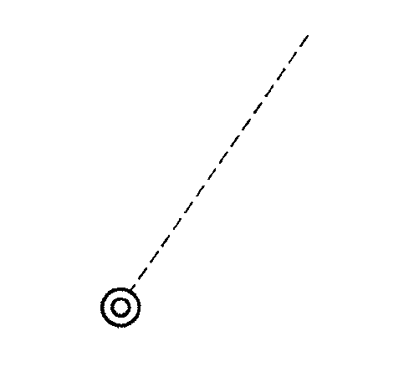
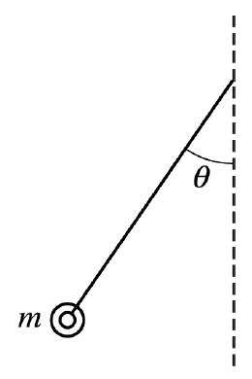
a. In the space to the right, draw a free-body diagram of the ring, showing and labeling all the forces present.

The plane reaches a takeoff speed of 65 m/s after accelerating for a total of 30 s.

b. Determine the minimum length of the runway needed.

c. Determine the angle θ that the string makes with the vertical during the acceleration of the plane before it leaves the ground.

d. What additional information would be needed in order to estimate the mechanical energy of the airplane at the instant of takeoff? Explain your answer.

2005B1 (10 points) The vertical position of an elevator as a function of time is shown below.
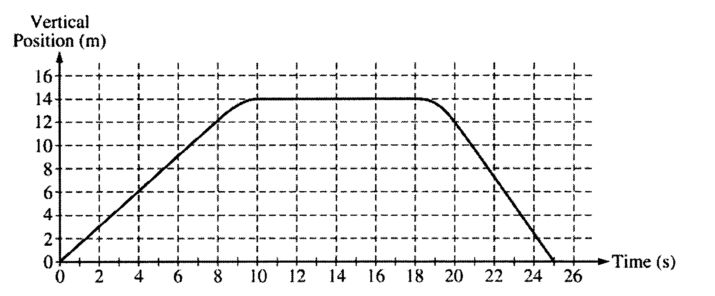

a. On the grid below, graph the velocity of the elevator as a function of time.
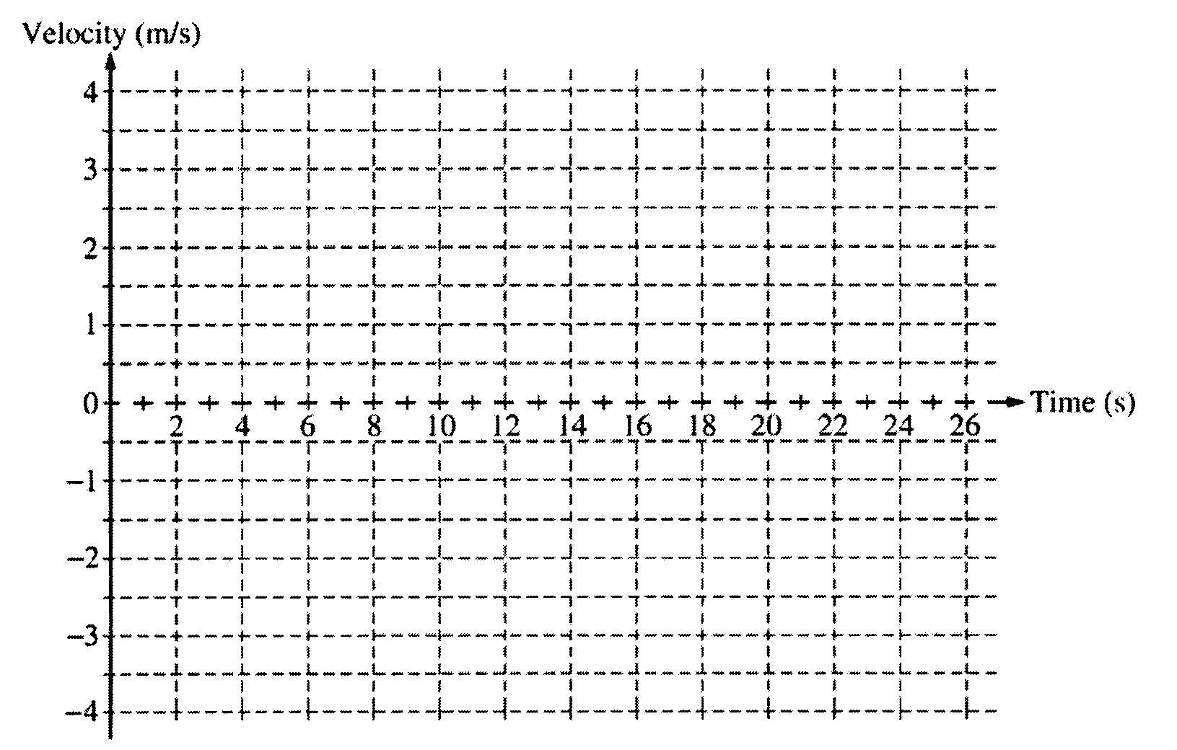

b. i. Calculate the average acceleration for the time period t = 8 s to t = 10 s.

ii. On the box to the right that represents the elevator, draw a vector to represent the direction of this
average acceleration.

c. Suppose that there is a passenger of mass 70 kg in the elevator. Calculate the apparent weight of the passenger at time t = 4 s.

2005B2 (10 points)A simple pendulum consists of a bob of mass 1.8 kg attached to a string of length 2.3 m. The pendulum is held at an angle of 30° from the vertical by a light horizontal string attached to a wall, as shown above.

a. On the figure below, draw a free-body diagram showing and labeling the forces on the bob in the position shown to the right.

b. Calculate the tension in the horizontal string.

c. The horizontal string is now cut close to the bob, and the pendulum swings down. Calculate the speed of the bob at its lowest position.

