Mr. Forrest /A. P. Physics 2014/2015 Name: ___________________________________
Date: ___________ Partners: _________________________________
Per. ____________ __________________________________
__________________________________

LAB: Forces and Energy of Springs and Carts (V1.0)

Materials:
3 springs of unknown spring constant 1 low friction track Assorted Masses
2 end stops 1 PascoCar String, pull pin
Spring launcher

Additional materials depending on methodology:
Motion sensor Force probe Computer with Logger Pro interface
Table top pulley Level Notecards for motion sensor detection

Procedure/Set Up of the cart (general overview):
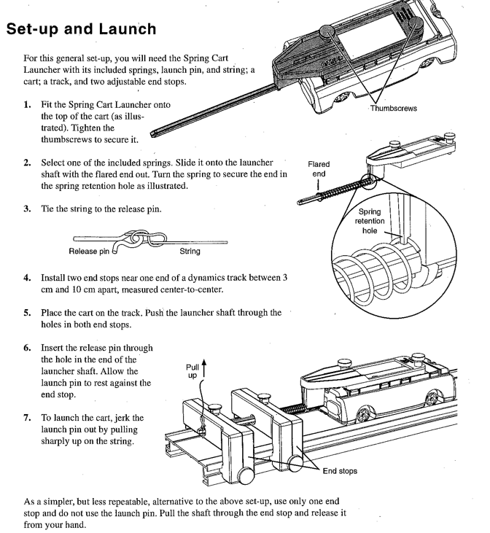

Theory:
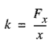
The spring constant of a spring is: Eq. 1

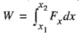
Where Fx is the force applied to the spring and x is the displacement of the end of the spring from its equilibrium position. As you push the end of a spring (or actually anything) from X₁ to X₂, the work that you do is equal to the area under the Fx vs. x graph, or the following, which represents the work done on the spring. Note that as the spring is compressed or stretched fr om the equilibrium position, the force is NOT constant, hence the reason the formula is calculus based as follows:
Eq. 2

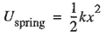
The potential energy stored in a spring is: Eq. 3

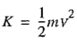
The kinetic energy for a cart moving on a track is: Eq. 4

And the change in gravitational potential energy for a cart moving up an inclined track is:
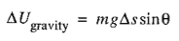
Eq. 5

where g is 9.8 m/s/s, ∆s is the distance traveled along the track in the uphill direction and θ is the angle of incline.

Overall Goals:

- Determine the spring constants of the black, blue and red springs included in your materials.

- Determine how the work done on a spring compares to the potential energy stored in the spring

- Determine whether the energy stored in a spring is conserved as it is transferred to the cart in the form of kinetic energy and/or then gravitational potential energy.

- Show all details, graphs and relevant calculations for your lab work.

Your group is a using a (circle one of the following) HIGHER TECH LOWER TECH methodology.

- Higher Tech setup start here!!!

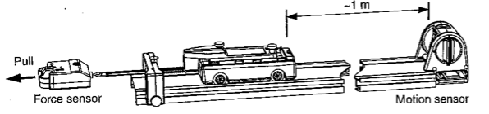

Higher Tech Method General Information:
In this experiment, a force sensor will measure the force you apply to a spring and a motion sensor will measure the displacement of the end of the spring as it is compressed (through measuring the end of the cart). The motion sensor can also determine the displacement and velocity of the cart.

1) Follow steps 1-3 on the ‘Set Up and Launch’ procedure from Page 1. Make sure to level the track.

2) Place an end stop somewhere toward the middle of the track, and place the motion sensor toward the end opposite the end stop.

3) Use a loop of light string to tie through the end of the cart launcher and loop the string onto the hook of the force probe.

4) Before opening Logger Pro, make sure the probes are connected to the computer. Once you open the program, several graphs should automatically appear. You can alter the type of graph you see by clicking on an axis and selecting a new data variable to appear there. In this way, we should be able to get graphs for: Position vs. Time, Velocity vs. Time, Force vs. Position and Force vs. Time.

5) Make sure you will be able to collect data for a long enough time and at a high enough rate. Click on the clock symbol, , at the top of the Logger Pro toolbar and adjust the settings so you have 20

seconds of data collection and at least 20 samples per second. (You can alter these again later if needed). To alter the time shown on the graphs, you will need to change the axes by clicking on the graphs and adjusting the scaling – OR, the graph may automatically extend if you collect enough data.

HT PART 1: Procedure for determining spring constant

1) Note what spring is attached to the cart in the data table on the next page. Make sure the cart is on the track with the spike of the launcher in the hole of the end stop. Show all calculations in the space by the data table as well.

2) Tie the string around the force probe that is on the end of the spike. Pull the cart back with the force sensor so that the end of the spring just touches the stop, but is not at all compressed. Do NOT leave tension on the string.
3) Press the Zero button on the Logger Pro toolbar [ ] to tare the force probe (you can also zero the motion sensor).

4) Start data collection and slowly pull back with the force probe until the spring is almost (but not quite) completely compressed. Stop collecting data at this point.

5) Determine the spring constant from the slope of the Force vs. Position graph.

6) Measure the area under the graph (you can use Logger Pro’s Integral function!). This area equals the work, W, you did on the spring.

7) From a graph, determine the displacement of the end of the spring. Use equation 3 (Eq. 3) from the previous page to determine the elastic potential energy stored in the spring after you compressed it.

8) Save your experiment on the desktop, then repeat steps 1-7 for the remaining springs using a new experiment each time. Record all data and show calculations by the data table on the next page.

Table 1 – Spring constant, work and energy

Spring type | Spring constant from slope of graph  (N/m) | Area of graph from integral function [Work]  (N*m) | Maximum displacement  (m) | Elastic potential energy at maximum displacement  (Joules)
1)
2)
3)

Calculations for elastic potential energy for each spring:

1) 2) 3)

QUESTION:

How well does the work you did on the spring compare with the potential energy stored in the spring?

HT PART 2: Elastic (spring) potential energy and kinetic energy

In this part of the lab, you’ll explore the relationship between the elastic potential energy initially stored in the spring and the kinetic energy of the cart just after it is launched. You will only need a motion sensor, NOT a force probe.

1) Place two end stops toward on end of the ramp, but not completely at the end. Have one end stop between 3 and 10 cm behind the other.

2) Choose one of the springs (based on color) that you tested earlier. Spring type: ___________________
Note the specific spring you use to the right.

3) Place the cart on the track so the spike of the launcher is through the hole in the first end stop. Position the cart so the spring is in touch with the end stop but not compressed.

4) Begin recording data. Wait a few seconds to let the sensor measure the uncompressed position, then push the launcher stick through both end stops and put the release pin (with string) into the hole on the end of the stick. Let the pin rest against the second end stop a few seconds (to let the sensor record the compressed position).
IMPORTANT: Make sure you have a partner who will be able to stop the cart before it runs into the sensor!
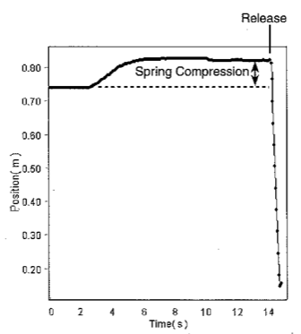
5) Pull out the release pin with a quick jerk to launch the cart. Stop data recording AFTER the launch but before the cart gets within 15 cm of the motion sensor (or before your partner stops it).

6) Determine the spring compression for the Position vs. Time graph. Then use the value for k you found earlier and Equation 3 to calculate Uspring. Fill the information in the data table below, and show calculations below the data table.

7) Use the Velocity vs. Time graph to find the velocity of the cart just after the launch. Measure the mass of the cart and attached devices (launcher and spring).

8) Calculate the kinetic energy of the cart using Equation 4 and record this in the data table. Show calculations below the data table.

9) Compare the initial potential energy of the spring with the kinetic energy of the cart. Show this in the data table.

10) Save the experiment file to the desktop.

11) Repeat steps 3-9 at least three more times, each time by starting a new experiment. Record all information in the data table. Within all of your trials, make sure you have at least two different amounts of compression (by moving one of the end stops) and at least two different masses (by securely taping a mass on the top of the cart).

Table 2: Spring type: __________________ Spring constant: ___________ N/m

Spring compression  [X final – X initial]  (meters) | Elastic potential energy [Uspring]  (Joules) | Velocity just after launch  (m/s) | Mass  (kg) | Kinetic energy just after launch  (Joules) | Difference in energy  [Uspring – KE]  (Joules)
1)
2)
3)
4)

Calculations for Uspring:

1) 2) 3) 4)

Calculations for KE:

1) 2) 3) 4)

QUESTION: Did the energy appear to be conserved through your trials? If so, how well? If not, describe your results and what patterns you see that might account for any differences. Think about where uncertainties and errors might most likely arise.

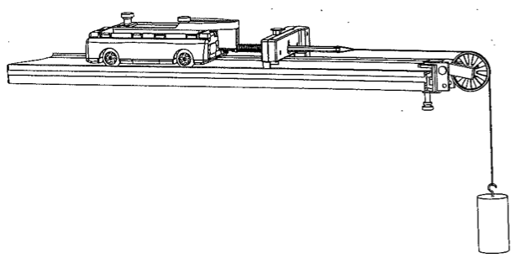
- Lower Tech setup start here!!!

Lower Tech Method General Information:

In these experiments (which do not require sensors) you will determine the spring constant by using a hanging mass to apply a known force. Later, you’ll determine the energy transferred to the cart by measuring the maximum height th cart reaches as it runs up an inclined track.

Note the type of spring by the color of the marking on it (red, blue, or black) for your experiments.
Low tech groups will only need to use one type of spring for this part of the lab.

1) Follow steps 1-3 on the ‘Set Up and Launch’ procedure from Page 1. Make sure to level the track so the cart does not roll.

LT PART 1: Procedure for determining spring constant

1) Install an end stop about 20 to 25 cm from the end of the track and clamp a pulley to the same end of the track.

2) Position the track so a mass hanging from the pulley is free to hang over the edge of your lab table.

3) Place the cart on the track so the end of the launcher stick goes through the hole in the end stop. Tie a piece of string around the end of the launching stick and hang it over the pulley. Make sure the end of the string has a loop in it so you can easily change masses.

4) Record the position of the cart with the spring up against the end stop without being compressed. This is the initial position of the cart.
5) Hang a 100 g mass from the end of the string and record the position of the cart on the track now as well as the total mass hanging from the end of the string. Calculate the compression of the spring by comparing this to the initial position of the cart.

6) Add mass (usually 100 g increments work well) until you have at least five widely spaced measurements for compression and mass. Make sure that you do NOT fully compress the spring, as those measurements may not be accurate.

7) Calculate the force applied to the spring by using Fx = m_{h}*g; where g = 9.8 m/s/s, and m_{h} is the hanging mass in kg. Record the information in the data table and show calculations below.

8) On the next page, make a graph of Fx vs. spring compression. Make sure to label the graph appropriately and make a line of best fit for the graph. The slope of the graph will be the spring constant, k.

9) Untie the string from the launcher for the next part of the lab.

Table 1 – Determining spring constant

Spring type: ______________ Initial cart position: ________ m

Mass added  (kg) | Applied force  (Newtons) | Final cart position  (meters) | Spring compression  (meters)
1)
2)
3)
4)
5)
6)

Work for determining applied force:

1) 2) 3) 4) 5) 6)

Graph for determining spring constant:

Calculation for spring constant based on your line of best fit:

Spring constant = __________ N/m

QUESTION:

1) How consistent was your data, and how confident do you feel with your determination of the spring constant?

LT PART 2: Elastic (spring) potential energy, kinetic energy and gravitational potential energy
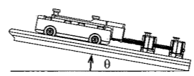
NOTE: Use the same spring you used for Part 1 of the lab

1) Place two end stops on the end of the track, as shown to the right.
Position the end stops between 3 cm and 10 cm apart.

2) Elevate the opposite end of the track by a reasonable amount. Start with about 20 cm of elevation, but you can change this if needed. Once you have a appropriate elevation, determine the angle of the track, either with a protractor, or (better yet) with trigonometry.

3) Hold the cart on the track with the launcher stick through the hole in the first end stop with the spring just touching the end stop, but not compressed. Record this position above the data table.

4) Push the end of the stick through both end stops and put the release pin into the stick. (See page 1 for a picture). Note the position of the cart now and record both this compressed position (As X₂) and the amount of spring compression (∆X) in the data table.

5) Pull the release pin with a quick jerk and watch the cart carefully as it goes up the track. Observe the highest position the cart reaches and try and read this to the nearest cm (or nearest 0.01 m). Record this position as X₃ in the data table. Determine the distance the cart traveled (∆s) by subtracting X₃ from X₂. Repeat the launch for the exact same conditions and record the average distance in the data table.

7) Use ∆X, the spring constant k from the previous part of the lab to calculate the initial elastic potential energy of the spring. Show work for the calculation below the data table.

8) Measure the mass of the cart with the launcher and spring attached. Record this in the data table.

9) Use Equation 5 to calculate the change in gravitational potential energy of the cart. Show work on the next page.

10) Repeat steps 3-9 at least three more times, each time by starting a new experiment. Record all information in the data table. Within all of your trials, make sure you have at least two different amounts of compression (by moving one of the end stops) and at least two different masses (by securely taping a mass on the top of the cart).

Table 2 Initial (uncompressed) position of cart: ______ m Angle of track: _______ °

Position of cart when compressed [X2]  (meters) | Spring compression  [∆X]  (meters) | Elastic potential energy  [Uspring]  (Joules) | Avg. position of cart at highest point on track [X3]  (meters) | Distance cart moved up the track  [∆S]  (meters) | Mass of cart  (kg) | Final gravitational potential energy  (Joules) | Difference in energy  [Uspring – Ugrav]  (Joules)
1)
2)
3)
4)
QUESTION: Did the energy appear to be conserved through your trials? If so, how well? If not, describe your results and what patterns you see that might account for any differences. Think about where uncertainties and errors might most likely arise.

FINAL QUESTIONS FOR ALL GROUPS TO ANSWER:
* Use the work-energy theorem to come up with work-energy bar charts for your initial and final conditions
* Make a position, velocity and acceleration time graphs for the low tech method of the cart on ramp.
1) Present a whiteboard with your overall results and be prepared to discuss them.
2) Why were low tech groups not able to directly determine the kinetic energy of the cart just after it left the spring?

- Is there any way those groups could do that indirectly?

3) Which of the two methods showed more of a ‘loss’ of energy? What do you think accounted for this?

4) After listening to whiteboard presentations, list a benefit and a drawback of each of the two methods.
HIGH TECH:

LOW TECH:

5) So overall, which method would you use if you had to do it all over and why?

